PROJECT SHOWCASE PLATFORM

SQL COMMANDS IMPLEMENTATION DOCUMENT

2. DATABASE OVERVIEW
Database Name: project_showcase
Description:
The database is designed to store user details, project information, user interactions such as likes and comments, and saved projects.
Tables Used:
- users
- projects
- project_likes
- comments
- saved_projects
SQL Commands Used:
SHOW DATABASES;

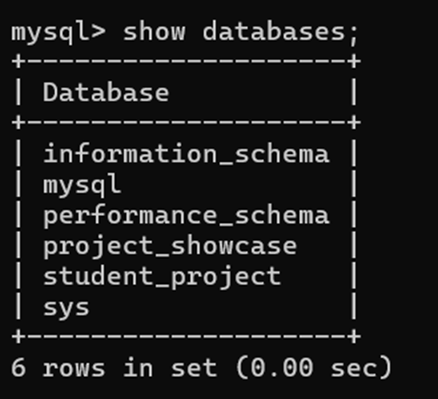

SHOW TABLES;
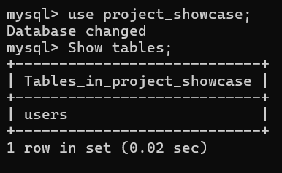

3. DDL – DATA DEFINITION LANGUAGE

3.1 CREATE COMMAND
Purpose:
The CREATE command is used to create tables in the database.
Implementation:
CREATE TABLE users (
user_id INT PRIMARY KEY AUTO_INCREMENT,
name VARCHAR(100),
email VARCHAR(100) UNIQUE
);
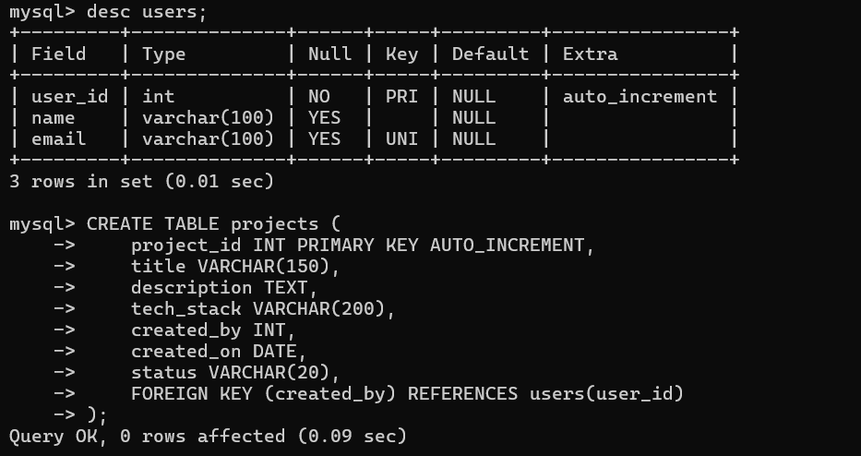
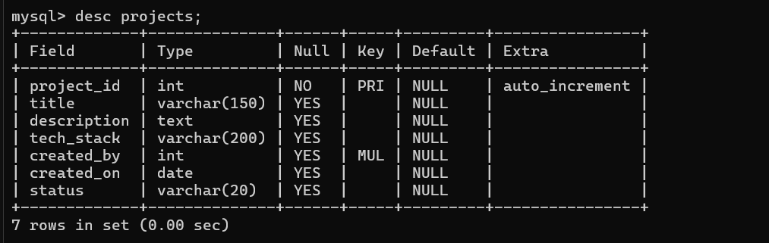
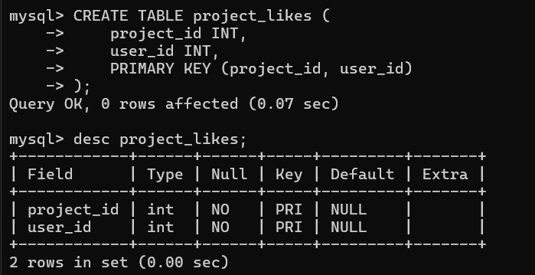

3.2 ALTER COMMAND
Purpose:
The ALTER command is used to modify the structure of an existing table.
Implementation:
ALTER TABLE projects ADD repo_link VARCHAR(200);

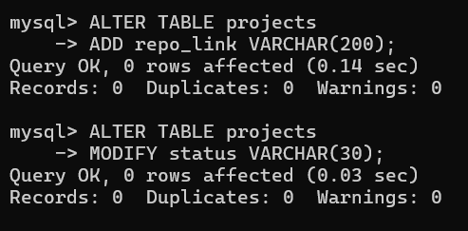

3.3 DROP COMMAND
Purpose:
The DROP command is used to permanently remove a table from the database.
Implementation:
DROP TABLE project_likes;

3.4 TRUNCATE COMMAND
Purpose:
The TRUNCATE command is used to remove all records from a table without deleting its structure.
Implementation:
TRUNCATE TABLE comments;

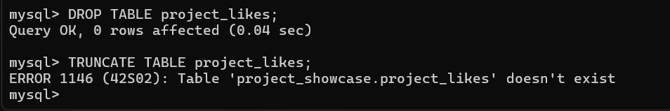

4. DML – DATA MANIPULATION LANGUAGE

4.1 INSERT COMMAND
Purpose:
The INSERT command is used to add new records into a table.
Implementation
INSERT INTO users (name, email)
VALUES ('Ratnesh Singh', 'ratnesh@gmail.com');
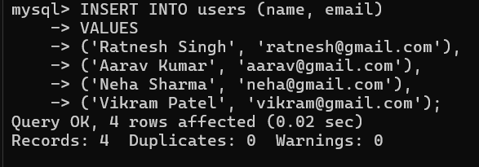
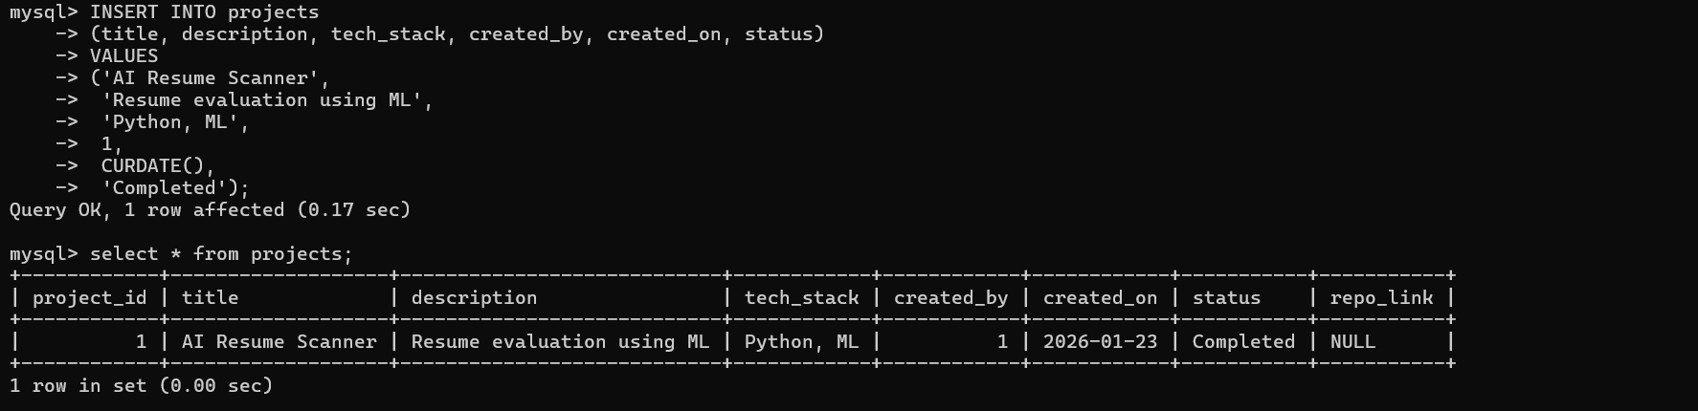

4.2 SELECT COMMAND
Purpose:
The SELECT command is used to retrieve data from a table.
Implementation:
SELECT * FROM users;
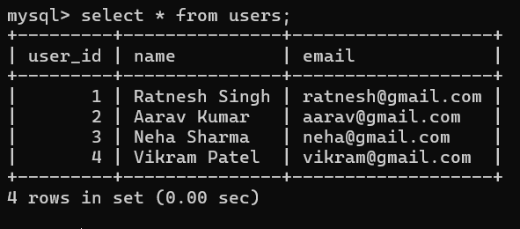

4.3 UPDATE COMMAND
Purpose:
The UPDATE command is used to modify existing records in a table.
Implementation:
UPDATE projects
SET status = 'Completed'
WHERE project_id = 1;

4.4 DELETE COMMAND
Purpose:
The DELETE command is used to remove specific records from a table.
Implementation:
DELETE FROM projects
WHERE status = 'Idea';

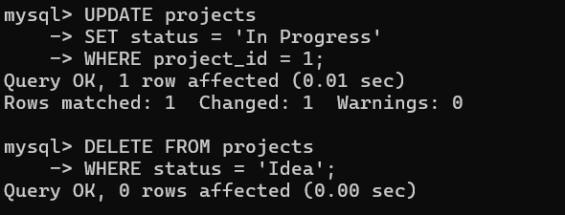

5. DQL – DATA QUERY LANGUAGE

5.1 AGGREGATE FUNCTIONS
Purpose:
Aggregate functions are used to perform calculations on data.
Implementation:
SELECT COUNT(project_id) AS total_projects FROM projects;
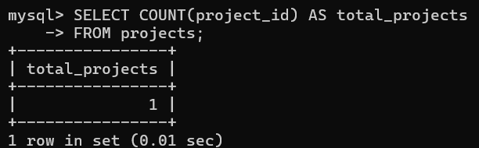

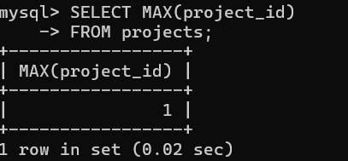


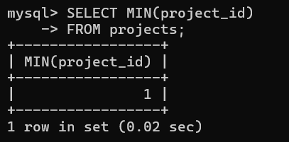
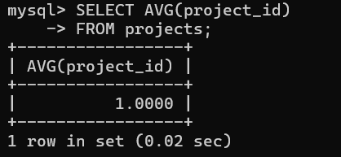

5.2 GROUP BY AND ORDER BY
Purpose:
GROUP BY groups records, and ORDER BY sorts the result set.
Implementation:
SELECT status, COUNT(project_id)
FROM projects
GROUP BY status
ORDER BY status;
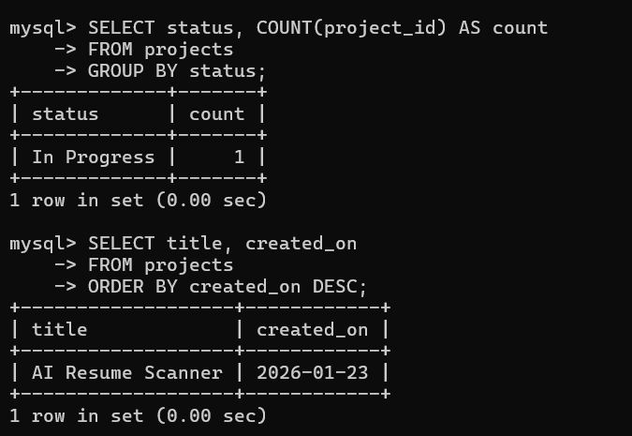

6. TCL – TRANSACTION CONTROL LANGUAGE

6.1 COMMIT COMMAND
Purpose:
The COMMIT command saves all transaction changes permanently.
Implementation:
BEGIN;
UPDATE projects SET status = 'Completed' WHERE project_id = 2;
COMMIT;
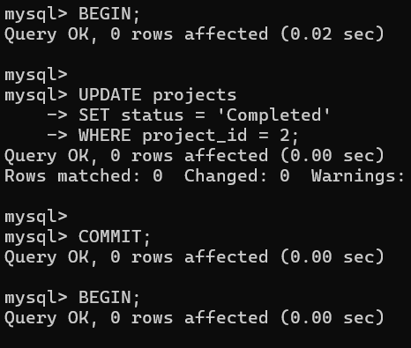

6.2 ROLLBACK COMMAND
Purpose:
The ROLLBACK command undoes changes made in a transaction.
Implementation:
BEGIN;
DELETE FROM projects WHERE project_id = 3;
ROLLBACK;
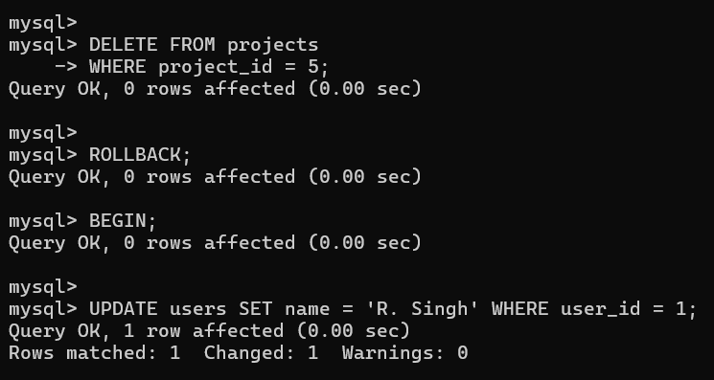

6.3 SAVEPOINT COMMAND
Purpose:
The SAVEPOINT command creates a checkpoint in a transaction.
Implementation:
SAVEPOINT sp1;
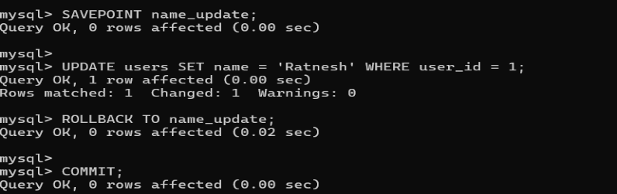

7. JOINS

7.1 INNER JOIN
Purpose:
The INNER JOIN is used to combine rows from multiple tables based on a condition.
Implementation:
SELECT p.title, u.name
FROM projects p
JOIN users u ON p.created_by = u.user_id;
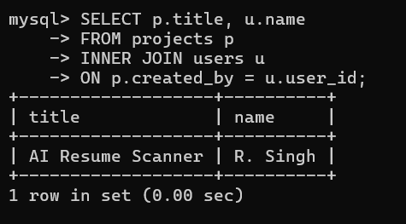

7.2 LEFT JOINS
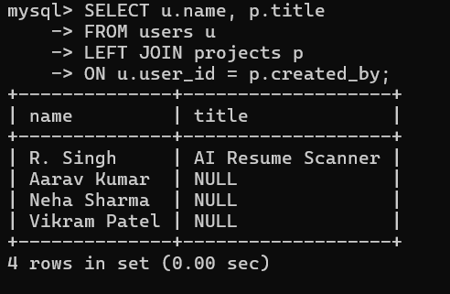

7.3 RIGHT JOIN

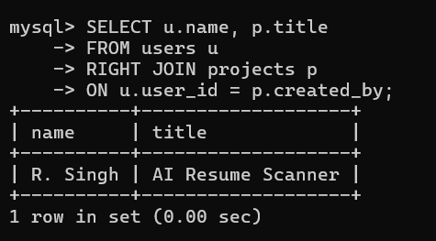

8. VIEW
Purpose:
A VIEW is a virtual table created using a SELECT query.
Implementation:
CREATE VIEW project_showcase AS
SELECT title, status FROM projects;
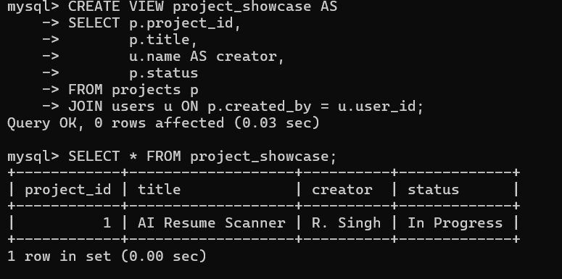

9. TRIGGER
Purpose:
A TRIGGER automatically executes when a specific database event occurs.
Implementation:
CREATE TRIGGER set_project_date
BEFORE INSERT ON projects
FOR EACH ROW
SET NEW.created_on = CURDATE();
